Fund-Level Sensitivity Analysis Draft

Introduction

Dimensions Varied
To date, we have conducted sensitivity analyses for seven facets/dimensions of the model that impact the allocation of $200M across funds. These are described further in sections below, and cover the allocation’s sensitivity to:
- Across-the-board changes in cost-effectiveness
- Worldview credences
- Aggregation method credences
- Risk aversion
- Diminishing marginal returns curves
- Time discounts for the far future
- Animal moral weights
- Key GCR model parameters

Summary
- Across-the-board shifts in cost-effectiveness
  - Extremely sensitive: Large (2–4 order-of-magnitude) increases in the GCR funds’ cost-effectiveness as a group shift over 20pp (e.g. +27pp), with Longview’s AI Fund gaining the most (up to +18pp) and most of that funding pulled from the animal welfare funds.
  - Highly sensitive: Order-of-magnitude changes to most individual funds (all except the animal welfare funds) shift roughly 10–16pp.
    - The GHD funds are the biggest individual lever: raising LEAF 1.5–2x moves +11 to +16pp (mostly from GiveWell), and raising GiveWell 1.5–2x moves +9 to +11pp (mostly from LEAF and TNF’s general fund).
    - Order-of-magnitude changes to individual GCR funds move ~10–13pp: Longview AI at 0.1x loses ~10pp (to Sentinel Bio and GiveWell), Sentinel Bio at 10x gains ~10pp, and Longview Nuclear at 10x gains ~11pp.
    - A systematic 4x overestimate of the animal welfare funds shifts ~12pp away from animal welfare and toward GiveWell.
    - If all GCR funds are 10x more cost-effective than modeled, 11 pp can be shifted towards them.
  - Moderately sensitive: Large (1–4 order-of-magnitude) decreases in the GCR funds’ cost-effectiveness as a group shift only ~10pp (mostly to GiveWell), far less than the equivalent increase, because some worldviews fund GCRs regardless while others sit near a tipping point that only an increase crosses.
  - Low sensitivity: Smaller changes (1.5x, 2x, 4x) to individual GCR funds barely move the allocation, as do minor relative differences between similar funds (a 20% gap between Sentinel Bio and Longview Nuclear shifts <1.5pp); diminishing-returns differences swamp small random fluctuations in the tails.
- Worldview Credences
  - Highly/Extremely sensitive: GCR causes–in particular, Longview’s AI fund–can gain up to 27pp from plausible shifts in the credences in worldviews (particularly towards risk-neutral views).
  - Moderately Sensitive: GiveWell could gain 6 to 9 percentage points from plausible increases in the credences assigned to risk-averse, person-affecting views that assign low moral weights to animals.
- Animal moral weights
  - Extremely sensitive:
    - Setting animal moral weights to their lowest considered levels shifts ~47pp (GiveWell gains 41pp), the only scenario that fully clears funding out of the animal welfare cause area;
    - A 10x across-the-board cut in moral weights moves ~24pp, mostly from TNF’s general farm animal welfare fund to GiveWell.
      - However, even this 10x cut leaves the three animal welfare funds with over 22% of the portfolio; only the lowest considered weights remove them from the allocation entirely.
  - Highly sensitive:
    - Raising weights to baseline or sentience-discount-only levels shifts ~16–19pp toward the animal welfare funds (mainly TNF’s general farmed animal welfare fund, at GiveWell’s expense).
    - Reducing weights by 80% multiplier moves ~14pp the other way, toward GiveWell.
  - Moderately sensitive: Reducing weights by 50% reallocates ~6pp away from TNF’s general farm animal welfare fund and toward GiveWell. No tested scenario fell below moderate sensitivity.
- Time discounts
  - Extremely sensitive: The allocation shifts 15 and 20 points from the GCR funds if one heavily or entirely discounts future effects that occur 500+ or 100+ years from now.
    - These effects start to kick in when the discount is on the order of ${10}^{-10}$ or smaller.
    - Animal welfare funds benefit the most from this shift, holding all other parameters equal.
  - Zero sensitivity: The allocation does not shift at all if the discounts on impacts in the 500+ year time frame is above ${10}^{-10}$.
  - Thus, the allocation seems to be most sensitive to differences between completely person-affecting/clueless views and views that give a non-negigible weight to the far future, rather than those who disagree about what non-negligible weight to assign to the far future.
- Risk aversion
  - The allocation is, across the board, extremely sensitive to changes in risk attitudes. This sensitivity arises from the risk-neutral and risk-averse worldviews having polar opposite views on the Longview Frontier AI Fund.
    - Risk neutrality drives nearly all of the funding to Longview’s Frontier AI fund.
    - WLU, upside skeptical, and the “combined” upside skeptical and downside critical views lead to large gains for GiveWell primarily, and the Navigation Fund’s general farmed animal welfare fund secondarily.
    - When we only care about avoiding harms, Sentinel Bio and Longview’s Nuclear Weapons Policy Fund benefit at the expense of Longview’s Frontier AI Fund.
      - The former two funds retain a small chance of having an enormous impact with less backfire risk.
- Diminishing Marginal Returns Curves
  - Low sensitivity: The rate at which returns diminish has little effect on the allocation, moving at most ~5pp even in the most affected case (GCR and animal welfare returns diminishing slowly).
  - Highly sensitive: The cap on how much funding each fund can absorb is a major lever, shifting ~10–15pp. Tightening the cap to 2.5x current budgets drives ~13pp to GiveWell; loosening it to 7.5–10x moves ~10–15pp to smaller funds (TNF cage-free fund, Sentinel Bio, Longview Nuclear), mostly out of TNF’s general farm animal welfare fund and GiveWell.
  - This points to prioritizing research into each fund’s true absorptive capacity; pinning down the exact rate at which returns diminish is a lower priority.
- Aggregation methods
  - Low sensitivity: The model is not very sensitive to shifts in the credences assigned to aggregation methods, at least under the levels tested.
    - Most aggregation methods that we placed substantial credence in diversify across funds and cause areas more than worldviews do.
    - This could change if one placed significant credence in Lexicographic maximin, which prefers to exclusively give to the two GHD funds.

Measure of Sensitivity
The primary metric we are using to assess the sensitivity of the Donor Compass to changes in parameter inputs is the total absolute change in allocation share to each fund that occurs upon a parameter change. This "total portfolio shift between funds” is calculated as:
$Fund TPS(p_{f}) = {\frac{1}{2}Σ}_{i∈funds}\left|S_{i}(p_{f})-S_{i}(p_{0})\right|$

For each fund, we take the absolute difference between its allocation percentage before $S_{i}(p_{0})$ and after the parameter change $S_{i}(p_{f})$, sum those differences across all eight funds, then divide by two. The result is in percentage points (pp). The sum is divided by two because each percentage gained by one fund is a percentage lost by another.

We also calculated the total portfolio shift at the cause area-level, so that we can see when between-cluster redistribution of funding happens and to separate it out from within-cause redistribution. However, in this report, we primarily focus on the total portfolio shift between funds.

Baseline Allocation
The baseline allocation was calibrated using Marcus’ ATC inputs, with a total of $200M allocated. I used a weighted average method to aggregate across aggregation methods, with weights as specified here.

Out of a total of $200M allocated, the model recommends the following split:

Cluster/Fund | Allocation ($M) | Percent of Funding
Animal Welfare | 93 | 46%
EA Animal Welfare Fund | 26 | 13%
TNF - General | 36 | 18%
TNF - Cage-free | 31 | 16%
Global Health and Development | 36 | 18%
GiveWell | 27 | 13%
LEAF | 10 | 5%
Global Catastrophic Risks | 71 | 35%
Sentinel Bio | 15 | 7%
Longview Frontier AI Fund | 46 | 23%
Longview Nuclear Weapons Policy Fund | 10 | 5%
Total | 200 | 100%

When grouped by traditional-EA cause area, just under half ($93M) is allocated to the three animal welfare funds, $36M (18%) to the global health and development funds, and $71M (35%) to the GCR funds.

Overall distribution of results

Fund-Level Sensitivity
The histogram below shows the distribution of how sensitive the allocation to each fund was to particular tests.
- Overall, 72 of the 121 tests moved 5 percentage points or less of the $200M between funds.
  - In particular, we see that all of the tests that vary credences in aggregation methods had small effects.
- Another 24 had moderate effects, shifting between 5 and 10 percentage points of funding.
- 17 tests showed high sensitivity, reallocating between 10 and 20 percentage points between funds.
- The remaining 8 tests had extreme effects on the allocation, moving over 20 percentage points of funding.
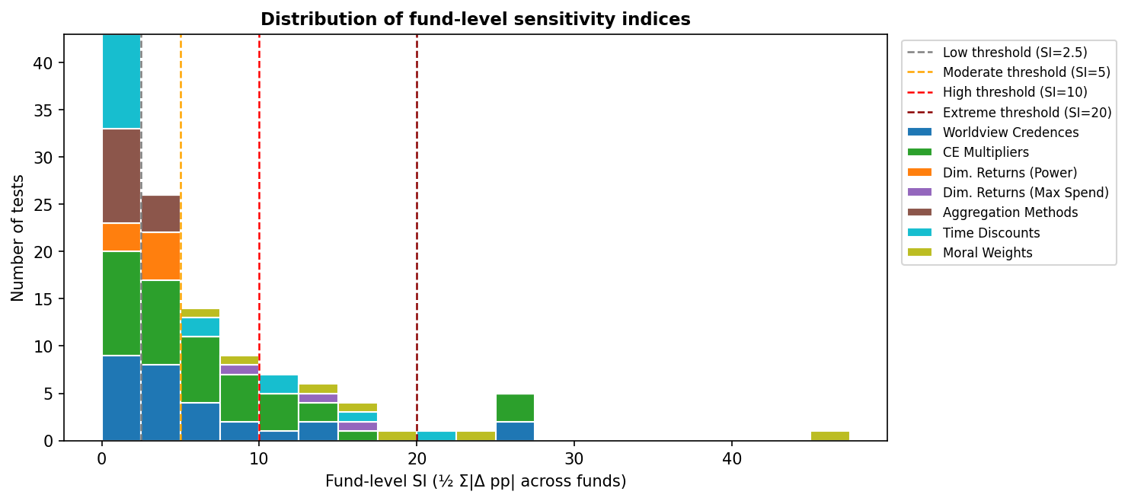
Note: risk-aversion scenario tests and analyses placing 100% credence in a single worldview or aggregation method are presented later as illustrative scenarios; they are excluded from the chart above since they were out of the bounds that Marcus puts credence in.

Compared to cause area-sensitivity
For comparison, the histogram below shows the distribution of how sensitive the allocation at the cause level was to all of the tests. We see that the results are pretty similar to the fund-level sensitivity analyses, but that there are more tests that show low sensitivity (under 2.5 percentage points moved). These tests must therefore result in small within-cause allocations instead of driving large between-cause reallocations.
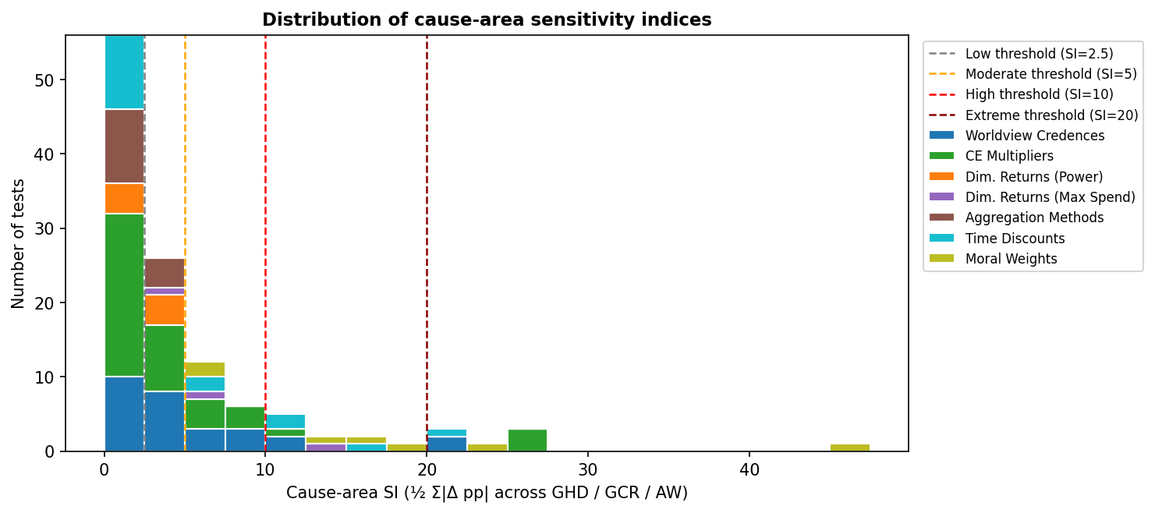

Sensitivity Analyses

Across-the-board changes in cost-effectiveness
Methodology
For this analysis, we wanted to see how much the allocations would change if we were empirically wrong about the cost-effectiveness of one or more funds. For instance, if we were off by a factor of 1.5x for GiveWell, or by 100x for the GCR funds.

For each sensitivity test, we scaled the cost-effectiveness of one or more funds by some multiple, recomputed the risk-adjusted scores for each fund, re-ran the allocation model, and computed how the allocation changed from baseline.

Fund(s) Varied | Multipliers
All GCR funds | 10e-4, 10e-3, 10e-2, 0.1, 10 10e2, 10e3, 10e4
Longview Nuclear | 0.1, 1.5, 2, 4, 10
Longview AI | 0.1, 2, 4, 10
Sentinel Bio | 0.1, 0.8, 2, 4, 10
All Animal Welfare Funds | 0.25, 0.5, 2, 4
EA Animal Welfare Fund | 0.5, 1.5, 2
Navigation Fund - Cage-Free | 0.5, 1.5, 2
Navigation Fund - General | 0.5, 1.5, 2
All Global Health and Development Funds | 0.5, 1.5, 2
LEAF | 0.5, 1.5, 2
GiveWell | 0.5, 1.5, 2

Results
Overall
- The allocation to each fund can be extremely sensitive (over 20 percentage points of funding shift) to 2-4 order-of-magnitude increases in the cost-effectiveness of the GCR funds as a group.
  - In this case, most of the additional funding for GCRs comes from the animal welfare funds.
  - The allocation is borderline moderately/highly sensitive to 2-4 order of magnitude decreases in the cost-effectiveness of the GCR funds as a group (around 10 pp of funding shifts.)
    - This discrepancy in impact is likely due to the fact that some worldviews are set on funding GCRs, regardless of a 2-4 order of magnitude drop in cost-effectiveness, whereas others are not at baseline funding GCRs but are near a tipping point where they could switch to doing so if there’s a 2 order of magnitude increase in cost-effectiveness of GCRs.
  - Since our GCR inputs are largely speculative, it doesn’t seem unlikely that we could be 2 orders of magnitude off or more in estimating the cost-effectiveness of GCR funds.
  - Additionally, a 1 order of magnitude change in the cost-effectiveness of the GCR funds as a whole produces a 7 to 11 pp shift in the allocation (7pp for a 10x decrease in cost-effectiveness, 11 pp for a 10x increase).
- The allocation is also highly sensitive to changes in the cost-effectiveness of individual funds (except the animal welfare funds).
  - GHD funds:
    - We find that if LEAF is 1.5x or 2x more cost-effective than our model estimates, then it receives 11 to 16 percentage points more funding than in the baseline.
      - This comes largely at the expense of GiveWell, but also to some extent from the Navigation Fund’s general animal welfare spending.
      - Similarly, if GiveWell is half as cost-effective as we model, then 11 percentage points shift towards LEAF, with much smaller gains by other funds.
    - If GiveWell is 1.5x to 2x more cost-effective than our model estimates, then about 9 to 11 percentage points are shifted towards it, largely from LEAF and the Navigation Fund’s general animal welfare fund.
  - The GCR funds’ allocations appear to be highly sensitive to 1 order of magnitude changes in their cost-effectiveness, but not substantially sensitive to smaller changes (e.g. 1.5x, 2x, 4x)
    - In our baseline model, we estimate that Longview AI’s spending reduces more of the total existential risk than does Sentinel Bio or the Longview Nuclear Weapons Policy Fund’s spending. This is largely because we assume that risks from AI are a higher fraction of overall existential risk than the other sources of risk. However, this could be a mistaken assumption.
    - If Longview AI’s spending is 10x less cost-effective than modeled, then about 13 percentage points shift, mostly from the AI fund to Sentinel Bio and GiveWell.
    - Similarly, if Sentinel Bio is 10x more cost-effective than we model, then it gains about 10 percentage points of funding, at the expense of the AI fund and GiveWell.
    - Longview’s Nuclear Weapons Policy Fund largely draws funding away from Sentinel Bio and GiveWell if its cost-effectiveness is increased by an order of magnitude.
  - As we can see, when an individual fund’s cost-effectiveness is changed, most of the shift in resources occurs at the cause level. However, this is not always the case: between 13% to 56% of this reallocation comes from funding being reallocated between causes.
    - In particular, it appears that at least certain worldviews that, under the baseline, prefer animal welfare interventions might reallocate a portion of their funding to GHD funds with relatively minor increases in the cost-effectiveness of the latter.
    - Interestingly, increases or decreases in the relative cost-effectiveness of individual GCR funds of about 1 order of magnitude have their largest out-of-cause-area impacts on the funding given to GiveWell.
- Finally, if we are systematically over-estimating the cost-effectiveness of the animal welfare organizations by 4x, then there is a significant reallocation away from animal welfare to GiveWell (12 percent of the funding).

Movement Within and Between Funds
Fund Varied | Total allocation shift (pp) | Between-cause allocation shift (pp) | Between-cause reallocation pct. (%) | Largest Gain | Largest Loss | Largest out-of-cause change
All GCR x100, 1000, or 10,000 | 27 | 27 | 100% | Longview AI (+18pp) | TNF - General (-11pp) | TNF - General (-11pp)
LEAF x2 | 16 | 3.6 | 22% | LEAF (+16pp) | GiveWell (-13pp) | TNF - General (-2.3pp)
AI x0.1 | 13 | 4.6 | 35% | Sentinel Bio (+4.5pp) | Longview AI (-10pp) | GiveWell (+3.4pp)
GW x0.5 | 13 | 1.8 | 14% | LEAF (+11pp) | GiveWell (-13pp) | Longview AI (+0.6pp)
All AW x0.25 | 12 | 12 | 100% | GiveWell (+9pp) | TNF - General (-9pp) | GiveWell (+9pp)
LEAF x1.5 | 11 | 1.7 | 15% | LEAF (+11pp) | GiveWell (-10pp) | TNF - General (-1.2pp)
GW x2 | 11 | 6.3 | 56% | GiveWell (+11pp) | LEAF (-4.9pp) | TNF - General (-4.9pp)
Nuclear x10 | 11 | 2.8 | 26% | Longview Nuclear (+11pp) | Sentinel Bio (-5pp) | GiveWell (-2.6pp)
Bio x10 | 10 | 3.8 | 39% | Sentinel Bio (+10pp) | Longview AI (-4.5pp) | GiveWell (-3.5pp)
All GCR x0.01, 0.001, or 0.0001 | 10 | 8.8 | 88% | GiveWell (+6.8pp) | Longview AI (-7.0pp) | GiveWell (+6.8pp)
GW x1.5 | 9.2 | 4.2 | 46% | GiveWell (+9.2pp) | LEAF (-4.9pp) | TNF - General (-3.1pp)

Other Tests

Minor Within-GCR Cost-Effectiveness Changes
We see some reassuring results when testing minor relative changes in the cost-effectiveness of GCR interventions.

For instance, take Sentinel Bio vs. the Longview Nuclear Weapons Policy Fund. Our inputs for these two organizations are largely similar, (though we do assume that Sentinel Bio faces a more gradual diminishing returns curve). Nevertheless, even when we run a million samples, the mean expected impact per $1M is approximately 20% higher for Sentinel Bio than for Longview’s nuclear fund. This is almost certainly the result of inevitable random fluctuations in the right-hand tails of the sampled distributions. As such, we should think that the cost-effectiveness of these organizations might be around 20% off of what we’d ideally like.

How much does this randomness affect the results? Under the baseline, Sentinel Bio receives a little less than 9% of the funding, whereas Longview's nuclear fund receives about 4% of the funding. So, we might think that the randomness is driving a significant difference in results. However, when we decrease the cost-effectiveness of Sentinel Bio by 20%, only about 0.8 percentage points of funding are lost by Sentinel Bio. Three-quarters of this decrease is gained by Longview’s Nuclear Weapons Policy Fund and a quarter is gained by GiveWell. Similarly, when we increase Longview’s Nuclear Weapons Policy Fund by 50%--such that it’s now more cost-effective than Sentinel Bio for the marginal dollar–only about 1.3 percentage points of funding shifts to the nuclear fund (1.1 percentage points coming from Sentinel Bio, and 0.2 percentage points from GiveWell).

In sum, there is likely some effect of randomness driving discrepancies between Sentinel Bio and Longview’s Nuclear Weapons Policy Fund. Nevertheless, at least with the current sample size and inputs combination, having minor discrepancies of 20% between these two funds does not seem to drive a meaningfully different allocation to either–a percentage point here or there. Diminishing returns differences likely overwhelm the small random fluctuations in the tails.

Worldview probabilities
As a recap, recall that we represent uncertainty about how to weigh different types of doing good and how risk averse we should be through including different worldviews. Each worldview will have a different preference about which fund to allocate each marginal $2M to. We then use aggregation methods to navigate the potential disagreements between worldviews and figure out where to spend the money. These aggregation methods take into account how much weight (credence) we place on each worldview. In this analysis, we tested the sensitivity of the model’s allocation of $200M to changes in how much weight we put on each of the 14 worldviews included in our baseline recommendations.

How Each Worldview Allocates
To get some intuition about how each worldview prioritized each fund, we first ran the model allowing each of the 14 worldviews included in it to divvy up the $200M allocation as it sees fit. (This is equivalent to putting 100% credence in one worldview at a time, bypassing any need to use aggregation methods). The resulting allocations for each worldview (whose parameters can be found here) are below.

We see considerable diversity amongst the worldviews’ preferences, with some generalizable patterns
- Risk neutrality favors AI (and animals, with high enough weights).
  - All but one of the risk-neutral views (shaded grey) places nearly all of their resources in Longview’s AI fund, which is estimated to have the highest cost-effectiveness of the GCR funds on average despite its higher probability of backfire.
  - This pattern is not absolute – animal welfare funds can receive the majority of the funding if one is suffering-focused and places high moral weights on animals.
- Risk-aversion favors GHD and animal welfare funds, with the balance depending on moral weights.
  - When the animal moral weights are high (e.g. 0.4 or higher for chickens), then animal welfare funds dominate the allocation.
  - At moral weights of 0.1 or below for chickens, GiveWell and LEAF tend to be preferred.
- The biorisk and nuclear weapons funds tend only to be preferred when one is very averse to causing harm (thus disapproves of the AI fund) yet doesn’t severely discount impacts in the far future or down-weight large positive outcomes.

We will discuss these driving factors in their own sensitivity analyses below.

Worldview
Worldview | Variant | EA AWF | TNF - Cage-free | TNF - General | GiveWell | LEAF | Longview AI | Longview Nuclear | Sentinel Bio
Total Utilitarianism | Default | 0% | 0% | 0% | 0% | 0% | 100% | 0% | 0%
Total Utilitarianism | Person-Affecting/Cluelessness, high animal weights, upside-skeptical | 17% | 16% | 42% | 17% | 2% | 6% | 0% | 0%
Total Utilitarianism | Weighted Linear Utility | 17% | 16% | 42% | 19% | 6% | 0% | 0% | 0%
Total Utilitarianism | High life value, risk averse, upside-skeptical | 17% | 16% | 42% | 20% | 5% | 0% | 0% | 0%
Total Utilitarianism | Suffering forward, clueless, high animal weights | 17% | 16% | 42% | 0% | 0% | 25% | 0% | 0%
Non-Utilitarian Consequentialism | Default | 0% | 0% | 0% | 0% | 0% | 100% | 0% | 0%
Non-Utilitarian Consequentialism | High Life Value, clueless, low animals | 0% | 0% | 0% | 0% | 0% | 100% | 0% | 0%
Non-Utilitarian Consequentialism | Person-Affecting/Cluelessness | 3% | 9% | 0% | 0% | 0% | 88% | 0% | 0%
Non-Utilitarian Consequentialism | Weighted Linear Utility | 7% | 16% | 5% | 64% | 8% | 0% | 0% | 0%
Contractualism | Animals baseline, downside critical | 17% | 16% | 33% | 0% | 0% | 0% | 15% | 19%
Contractualism | Person-Affecting/Cluelessness, Animals Baseline, Risk Neutral | 0% | 0% | 0% | 0% | 0% | 100% | 0% | 0%
Contractualism | Default + cluelessness | 0% | 0% | 0% | 93% | 7% | 0% | 0% | 0%
Kantianism | Low animals | 0% | 0% | 0% | 95% | 5% | 0% | 0% | 0%
Kantianism | Low animals + downside critical | 0% | 0% | 0% | 97% | 3% | 0% | 0% | 0%

Methodology
The results above are informative, but we argue that one should not assign 100% credence to any particular worldview. Instead, we needed to test the sensitivity of the allocation to reasonable changes in the credences assigned to each worldview.

By way of background, the baseline model configuration relies upon the central estimate credences that Marcus Davis applies to each worldview. However, he is himself uncertain about these credences, and assigned upper and lower bounds to the credence he believes he could reasonably place upon each worldview.

So, for this analysis, we tested what happens to the overall allocation if the credence placed in each worldview is, one at a time, either raised to Marcus’ upper bound assigned to it, or lowered to its lower bound he assigned. To make sure all credences add up to 1, we redistribute the excess credence or draw the deficient credence from each worldview in proportion to that worldview’s baseline credence.

The following table captures all of the scenarios we tested, for each worldview.

Worldview | Baseline credence | Sensitivity tests on credence
Total Utilitarianism (Default) | 10% | - Raised to 25%  - Lowered to 5%
Total Utilitarianism (Person-affecting/clueless, sentience only discounts, upside skeptical) | 10% | - Raised to 20%  - Lowered to 5%
Total Utilitarianism (Moderate weighted linear utility) | 10% | - Raised to 20%  - Lowered to 5%
Total Utilitarianism (High life value, downside critical, upside skeptical) | 5% | - Raised to 15%  - Lowered to 2%
Total Utilitarianism (Suffering-forward, clueless, sentience-only discount) | 5% | - Raised to 15%  - Lowered to 2%
Non-Utilitarian Consequentialism (Default) | 5% | - Raised to 20%  - Lowered to 2%
Non-Utilitarian Consequentialism (High life value, clueless, low animal weights) | 5% | - Raised to 15%  - Lowered to 2%
Non-Utilitarian Consequentialism (Person-affecting/clueless) | 5% | - Raised to 20%  - Lowered to 2%
Non-Utilitarian Consequentialism (moderate weighted linear utility) | 5% | - Raised to 15%  - Lowered to 2%
Contractualism (Baseline animal weights, downside critical) | 5% | - Raised to 15%  - Lowered to 2%
Contractualism (Person-affecting/clueless, baseline animal weights, risk-neutral) | 10% | - Raised to 15%  - Lowered to 2%
Contractualism (Default) | 5% | - Raised to 15%  - Lowered to 2%
Kantianism (low animal weights) | 5% | - Raised to 20%  - Lowered to 1%
Kantianism (low animal weights, downside critical) | 10% | - Raised to 20%  - Lowered to 1%

Results
The table below suggests that the GCR causes–in particular, Longview’s AI fund–have the most to gain from plausible shifts in the credences in worldviews (particularly towards risk-neutral views, which are color-coded with grey).
- Increasing the credence in two risk-neutral views–in particular, the default total utilitarian and non-utilitarian consequentialist views–from baseline (10% and 5%) to the highest values in Marcus’ confidence interval (25% and 20%) could shift 27 percentage points of funding to Longview’s AI program.
  - These two views don’t discount impacts on the far future by as much as the other (even risk-neutral) worldviews do, hence they favor GCR interventions that could have large future payoffs.
- Similarly, reducing one’s credence in the risk-averse version of utilitarianism (which downweights large positives and upweights large negatives) drives funding away from less risky funds (like the animal welfare funds, but also the other GCR funds) towards Longview’s AI Fund
- Interestingly, both Sentinel Bio and Longview’s Nuclear Weapons Policy Fund gain significantly (the former by 9 percentage points) when one increases their credence in a risk-averse, person-affecting form of contractualism from 10% to 25%.
  - This comes at the expense largely of GiveWell.
Nevertheless, GiveWell could gain up to 9 percentage points from plausible increases in the credences assigned to risk-averse, person-affecting views that assign low moral weights to animals.
- Both forms of Kantianism represented are highly risk averse, and they assign very low moral weights to animals (e.g. 0.001 to a year of chicken suffering relative to a human year of suffering.)
  - Increasing credence in them to a maximum of 20% could drive 5.7 to 7.9 percentage points of funding to GiveWell.
  - LEAF also benefits to a lesser extent (about 0.4 percentage points).
- The default version of contractualism that could increase GiveWell’s allocation by 8.6 percentage points if its credence is raised to 15% is moderately risk averse, has low animal weights (0.004 for chicken suffering relative to humans), and entirely discounts effects on the future beyond 100 years.

Worldview
Worldview | Credence shift | Total portfolio shift | Between-causes shift | Share of total shift is between causes (%) | Largest Gain | Largest Loss
Total Utilitarianism (Default) | 10% to 25% | 27 | 22 | 78% | Longview AI (+27pp) | TNF - General (-9.2pp)
Non-Utilitarian Consequentialism (Default) | 5% to 20% | 27 | 21 | 79% | Longview AI (+27pp) | TNF - General (-9.8pp)
Total Utilitarianism (Weighted Linear Utility) | 10% to 5% | 14 | 12 | 86% | Longview AI (+14pp) | TNF - General (-5.8pp)
Contractualism (Person-Affecting/Cluelessness and Animals Baseline) | 10% to 25% | 14 | 10 | 68% | Sentinel Bio (+8.6pp) | GiveWell (-5.1pp)
Non-Utilitarian Consequentialism (Person-Affecting/Cluelessness) | 5% to 20% | 12 | 11 | 88% | Longview AI (+12pp) | TNF - General (-5.6pp)
Contractualism (Default + cluelessness) | 5% to 15% | 9.2 | 8.4 | 98% | GiveWell (+8.0pp) | TNF - General (-4.5pp)
Kantianism (Low animals) | 5% to 20% | 7.9 | 7.9 | 100% | GiveWell (+7.4pp) | Longview AI (-4.1pp)
Kantianism (Low animals / downside critical) | 10% to 20% | 6.2 | 6.2 | 100% | GiveWell (+5.7pp) | Longview AI (-3.0pp)
Contractualism (Person-Affecting/Cluelessness and Animals Baseline - Risk Neutral) | 10% to 20% | 5.4 | 5.4 | 100% | Longview AI (+4.7pp) | GiveWell (-2.9pp)
Kantianism (Low animals / downside critical) | 10% to 1% | 5.3 | 5.3 | 99% | Longview AI (+2.3pp) | GiveWell (-5.3pp)
Non-Utilitarian Consequentialism (High Life Value / Cluelessness / Low animals) | 5% to 15% | 5.3 | 5.3 | 100% | Longview AI (+4.4pp) | GiveWell (-2.1pp)

Aggregation method probabilities
Another source of uncertainty we had in setting the model defaults was how to adjudicate between competing recommended allocations amongst worldviews that we place non-zero credence in. That is, if risk-neutral total utilitarianism recommends 100% of the funding go to Longview AI, and Kantianism recommends it go to GiveWell and LEAF, and so on, how do we actually decide where to put the money?

There are a number of possible aggregation methods that can be used to solve this allocation problem when there are competing worldviews, and we included seven in the model: Nash bargaining, moral marketplace, maximizing expected choiceworthiness, maximizing expected truthlikeliness, split cycle voting, Borda voting, and lexicographic maximin. You can read more about these methods here.

As with the worldviews, Marcus assigned credences to each of these seven aggregation methods, with lower and upper bounds and a central estimate, in proportion to how sound he believes they are. When run, the model lets each aggregation method allocate the whole $200M. To get our baseline recommendation, we take the credence-weighted average allocation from all of these aggregation methods.

Methodology
In our sensitivity analysis, we estimate how the allocations shift between funds when we raise or reduce the weight given to each of these aggregation methods from their central estimate values to the upper or lower bound specified by Marcus. This process is very similar to that which we took for testing the sensitivity to worldview credences. These tests are catalogued in the following table.

Aggregation Method | Baseline credence | Sensitivity tests performed
Nash bargaining | 35% | - Raise to 50%  - Lower to 15%
Moral marketplace | 30% | - Raise to 50%  - Lower to 15%
Maximizing Expected Choiceworthiness (MEC) | 15% | - Raise to 20%  - Lower to 10%
Lexicographic Maximin | 0% | - Raise to 5%
Split Cycle Voting | 8% | - Raise to 10%  - Lower to 2%
Borda Voting | 2% | - Raise to 5%  - Lower to 0%
Maximizing Expected Truthlikeliness (MET) | 10% | N/A (Marcus did not assign a range of credences to MET)

What Each Aggregation Method Recommends
To get a good intuition for the sensitivity test results, it can be helpful to see what each of the individual aggregation methods recommends. The preferred allocation across funds by each method, plus the weighted-average baseline, is shown in the chart below.
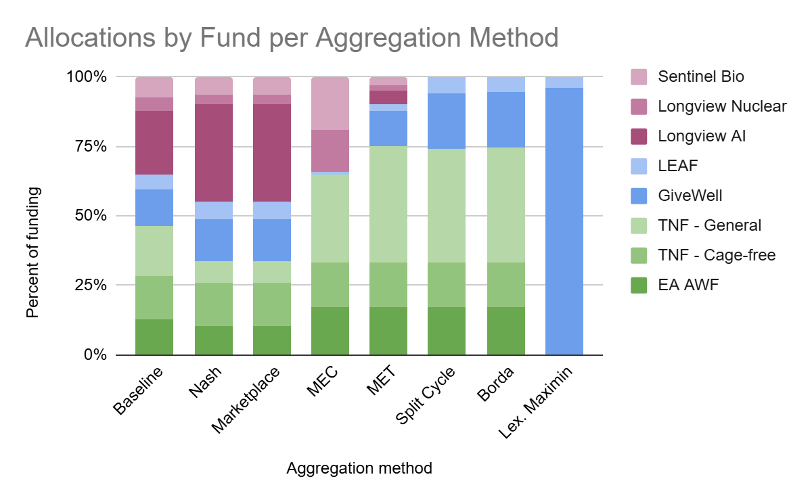
*Marcus does not assign any credence to Lexicographic maximin in his overall takes, but he thinks he could assign up to 5% to it, so we include it in this analysis.

All aggregation methods that Marcus places some credence in recommend some level of cause-level diversification. We see there is some moderate disagreement between these methods in their recommendations. Nash bargaining and marketplace have very similar recommendations because they, in practice, often perform the same calculations. These are the only two voting methods that recommend a substantial percentage of the donation be given to Longview AI, and they recommend much less be given to animal welfare funds.

By contrast, the other aggregation methods typically recommend the majority of the funding goes to the three animal welfare causes. The only exception is lexicographic maximin, which strictly prefers GiveWell and LEAF, and to which Marcus assigns zero credence as a central estimate. Interestingly, if they give to GCRs at all, these other methods give relatively more to the less-risky GCR interventions than they do to Longview AI.

Because 65% of the total weight is given to Nash bargaining and marketplace, then the baseline recommendation looks similar, with a high percentage of the funding given to Longview AI. Nevertheless, the percentage of funding that is given to animal welfare funds is increased by the 35% of the credence that is given to aggregation methods that significantly prefer animal welfare funds.

Results
At least with the scenarios tested, we do not find the results to be significantly sensitive to the weight assigned to each aggregation method.
- All scenarios tested shifted the resulting allocation by less than 5 percentage points.
- The largest shift that occurred (4.7 pp) was when the credence in Nash bargaining was lowered from 35% to 15%.
  - Consistent with the chart above, this was to the gain of the Navigation Fund’s general farmed animal work, and to the loss of Longview’s AI fund.
- Similarly, increasing the credence in the Nash bargaining or marketplace method from 30% to 50% could move about 3-4 percentage points, largely to Longview’s AI Fund.
- Interestingly, however, a small shift in the credence given to lexicographic maximin from 0% to 5% can increase GiveWell’s allocation by 4.2 percentage points–nearly all of which comes from other cause areas.
  - This is still a small shift in absolute terms, but a relatively large increase for GiveWell.
All other tests moved less than 2.5 percentage points of resources between funds.

Method | Scenario | Total portfolio shift | Between-cause shift | Share of shift is between causes (%) | Largest gain | Largest loss
Nash Bargaining | 35% to 15% | 4.7 | 4.0 | 84% | TNF - General (+3.2pp) | Longview AI (-3.6pp)
Marketplace | 30% to 50% | 4.4 | 3.7 | 84% | Longview AI (+3.4pp) | TNF - General (-3.0pp)
Lexicographic Maximin | 0% to 5% | 4.2 | 4.1 | 99% | GiveWell (+4.2pp) | Longview AI (-1.2pp)
Nash Bargaining | 35% to 50% | 3.5 | 3.0 | 84% | Longview AI (+2.7pp) | TNF - General (-2.4pp)

Of course, these results are dependent upon the baseline, lower bound, and upper bound credences Marcus assigned to each aggregation method. Others who start with quite different aggregation method preferences could see sharper changes in the allocation results with small shifts in credences.

Nonetheless, unless one is placing substantial high credence in Lexicographic maximin, it appears that the model’s recommendations are not nearly as sensitive to aggregation method choice as they are to worldview choice. This result is likely downstream of the fact that aggregation methods tend to diversify, whereas single funds or cause areas can dominate a given worldview.

Time discounts in the 100-500 year and 500+ year periods

Methodology
Recall that when we investigated the sensitivity of the allocation to credences in each worldview, we discovered that, in addition to moral weights and risk attitudes, an important feature of worldviews to which the allocation was sensitive was how one weights the far future.

As such, in this sensitivity analysis, we tested what would happen if we changed how each worldview weights impacts in the 100-500 year and 500+ year ranges. To do so, we selected multipliers that adjusted, across the board, the weights that each worldview assigns to effects in these two periods. We chose to apply the discount to the 500+ year timeframe alone, and then included the 100-500 year time frame as well to see if discounting the 100-500 year timeframe makes a difference.

For instance, in the “Discount 500+, 0.01” scenario (see the table below), the default total utilitarianism weight for the 500+ year timeframe falls from 0.01 to 0.0001. In the “Discount 100-500 and 500+, 0” scenario, all of the worldviews become maximally person-affecting, and don’t give any weight to effects beyond 100 years.

Results
Overall, the allocation appears to be highly sensitive to discounting effects in the 100-500 and 500+ year window by ${10}^{-12}$ to ${10}^{-15}$ or more (that is, using a multiplier of ${10}^{-10}$). The effects of this, understandably, are to shift funding away from the GCR interventions–mainly Sentinel Bio and Longview AI–and towards marginal animal welfare funds and, to a lesser extent, GiveWell. Entirely discounting the future 500+ years from now could shift up to 15 points of funding, and entirely discounting the future 100+ years from now could shift up to 20 points.

By contrast, the allocation does not budge for multipliers of ${10}^{-7}$ or larger. This suggests that if one gives any non-trivial weight to the far future, at least some worldviews will substantially prefer GCR interventions over others. The real divide, then, is not primarily between those who assign full weight to the far future and those who discount it by some amount, but between those who have near total or total person-affecting/clueless views and those who give some weight to the far future. (Of course, altering some of the parameters governing the GCR model, such as long-run existential risk levels, the probability of settling the stars, or the rate at which we do so, could change this assessment).

Scenario | Time discount multiplier | Total portfolio shift | Between-cause portfolio shift | Share of SI is between clusters (%) | Largest gain | Largest loss
Discount 500+ | 1E-07 | 0.0 | 0.0 | NA | NA | NA
Discount 500+ | 1E-08 | 0.3 | 0.3 | 100% | EA AWF (+0.2pp) | Sentinel Bio (-0.2pp)
Discount 500+ | 1E-09 | 7.3 | 7.3 | 100% | EA AWF (+3.5pp) | Sentinel Bio (-5.7pp)
Discount 500+ | 1E-10 | 12.0 | 12.0 | 100% | TNF - General (+6.5pp) | Sentinel Bio (-5.7pp)
Discount 500+ | 0 | 15.4 | 15.4 | 100% | TNF - General (+8.4pp) | Sentinel Bio (-6.6pp)
Discount 100-500 and 500+ | 1E-07 | 0.0 | 0.0 | NA | NA | NA
Discount 100-500 and 500+ | 1E-08 | 0.3 | 0.3 | 100% | EA AWF (+0.2pp) | Sentinel Bio (-0.2pp)
Discount 100-500 and 500+ | 1E-09 | 7.3 | 7.3 | 100% | EA AWF (+3.5pp) | Sentinel Bio (-5.7pp)
Discount 100-500 and 500+ | 1E-10 | 12.1 | 12.1 | 100% | TNF - General (+6.6pp) | Sentinel Bio (-5.7pp)
Discount 100-500 and 500+ | 0 | 20.9 | 20.9 | 100% | TNF - General (+11pp) | Longview AI (-8.8pp)

Animal moral weights
Based on the results from the worldview credence sensitivity analyses, we tested the sensitivity of the allocation to changes in the moral weights we assign to animals.

Methodology
Our model included effects for five broad categories of animals: chickens, fish, shrimp, non-shrimp invertebrates, and mammals. Since there are so many possible combinations of moral weights we could test, we stuck to modifying all of the animals’ moral weights at once in these sensitivity analyses.

In the baseline model, each worldview uses one of five sets of moral weights. Some worldviews are especially animal-friendly, and discount a year spent in DALY-equivalent pain by an animal only to the extent that we have doubts about its sentience. On the other side of the spectrum, the Kantian worldviews nearly entirely discount animal welfare–a year spent in pain by a chicken counts only 1/1000th as much as a year spent in equivalently intense pain by a human.

In our sensitivity analyses, we wanted to test the effects of setting the animal moral weights of all worldviews to one of four sets of values, shown in the table below. (Green text means the set has higher moral weights than the average across worldviews, and red text means that the moral weights are lower than the average across worldviews).

 | Sentience-Only Discount | Baseline weights | Moderate weights | Lowest weights
Chickens | 0.75 | 0.4 | 0.1 | 0.001
Fish | 0.6 | 0.24 | 0.06 | 0.001
Shrimp | 0.25 | 0.08 | 0.02 | 0.0001
Non-Shrimp Invertebrates | 0.2 | 0.07 | 0.02 | 0.0001
Mammals | 0.9 | 0.44 | 0.11 | 0.005

Additionally, we tested scenarios wherein we kept the current relative differences in moral weights between worldviews, but instead scaled them by some factor between 0 and 1 (0.1x, 0.2x, and 0.5x).

Results
The allocation is moderately to extremely sensitive to choices in animal moral weights, and the effects of changing them substantially impact the allocation to GiveWell. Nevertheless, even a 10-fold across-the board reduction in moral weights for animals still results in a significant portion of the portfolio being allocated to the EA AWF and The Navigation Fund’s two programs.
- If we are overestimating the moral weights of animals by 2-5x, then fixing this would reallocate 6 to 14 points, largely away from the Navigation Fund’s general farm animal fund (which appears to be on the margin of animal welfare spending) and towards GiveWell.
- If we are overestimating animals’ moral weights by 10x, then fixing this would re-allocate 24 points, largely from the Navigation Fund’s general farmed animal work and towards GiveWell.
  - Interestingly, the Navigation Fund’s cage-free fund is still highly rated by the worldviews and only sees a 2 percentage point drop in its allocation (from 16% to 14%).
  - Overall, since some worldviews still rate animal welfare funds highly even with 10x lower moral weights, the total allocation to the three animal welfare funds remains over 22%.
- It’s only when we set the animal moral weights to their lowest considered levels that we see a total re-allocation of funding away from the animal welfare cause area (mostly towards GiveWell).
- By contrast, 16 to 19 percentage points of funding could shift towards the animal welfare funds if moral weights for animals are set at their baseline levels (e.g. 0.4x for chickens) or sentience-discounted only levels for all worldviews.
  - The Navigation Fund’s general fund is the main beneficiary, and GiveWell loses the most from this change.

Scenario | Total portfolio shift (pp) | Between-causes portfolio shift (pp) | Share of shift between-causes (%) | Largest gain | Largest loss
Lowest weights | 47 | 46 | 98% | GiveWell (+41pp) | TNF - General (-18pp)
0.1x multiplier | 24 | 24 | 100% | GiveWell (+21pp) | TNF - General (-15pp)
Sentience-only adjustment | 19 | 19 | 100% | TNF - General (+15pp) | GiveWell (-9.4pp)
Baseline weights | 16 | 16 | 100% | TNF - General (+12pp) | GiveWell (-9.2pp)
0.2x multiplier | 14 | 14 | 100% | GiveWell (+11pp) | TNF - General (-11pp)
Moderate weights | 8.2 | 6.1 | 75% | GiveWell (+5.3pp) | TNF - General (-7.4pp)
0.5x multiplier | 6.1 | 5.8 | 96% | GiveWell (+3.6pp) | TNF - General (-4.9pp)

It’s interesting to note that maxing out our moral weights at the sentience-discount only values only shifts 19 points of funding towards animal welfare funds, whereas a 10x reduction in moral weights drives 24 points away from the cause. At a 10x discount, the average moral weight for chickens is still between 0.01 and 0.04, which is not actually that low. As such, it appears that animal welfare cause areas have, overall, more funding to lose than they have to gain, within reasonable parameters. Why is this?

If we look at where the individual worldviews would spend the $200M if we give them 100% credence, we see that the most animal-friendly ones max out their spending on animal welfare. As a result, increasing the animal moral weights only drives more spending to these areas if the moral weights in less-animal friendly worldviews hit a tipping point and start allocating funds to them.

Diminishing marginal returns curves

One of the areas where we are the least certain about our model assumptions concerns the diminishing returns rate for our funds. Specifically, we are highly uncertain about:
- Funds can only reasonably absorb so much money. At what level of additional funding, relative to a fund’s existing budget, should we assume that the marginal returns to spending fall to effectively zero (they’re unable to spend it)?
- Before that point, how quickly do returns to funds’ additional spending diminish?

In this section, we analyse both of these questions. We find that the allocation shows low sensitivity to changes in the rate of diminishing returns.

By contrast, the allocation is highly sensitive to the choice of upper limit that we place on the amount of additional spending each fund can absorb. This is likely because certain worldviews seem to prefer certain funds by a good margin, and only tend to diversify once the first-ranked fund runs out of absorptive capacity.

As a result, we should likely put significantly more effort into determining the maximum amount of funding each fund can reasonably absorb. It’s a relatively low priority to determine the exact rate at which spending’s returns decline before that point.

Changes in Rate of Diminishing Returns
Our diminishing marginal returns curves for the three animal welfare and GCR funds are constructed by assuming that the marginal cost-effectiveness falls by a constant percentage per percent change in the fund’s budget. This constant, or elasticity, however, is subject to significant uncertainty.

Using estimates from the funds, external advisors, and our own internal consultations, we assumed that each percentage point increase in a fund’s budget is associated with a decline in the marginal cost-effectiveness by the amounts indicated in the table below.

 | Percent decline in marginal cost-effectiveness per 1% increase in budget
Fund | Lower bound | Central (baseline) | Upper bound
All GCR Funds | 0.35 | 0.9 | 1.3
EA AWF | 0.6 | 0.9 | 1.1
TNF - Cage-Free | 0.6 | 0.9 | 1.1
TNF - General | 0.9 | 1.3 | 1.6

In our sensitivity analyses, we tested eight different combinations of the lower, central, and upper estimates of the rate at which returns diminish within cause areas. (Using the lower bound means that marginal returns diminish slowly, whereas using the upper bound means returns diminish quickly). For each combination, we computed the recommended allocation to each fund, and computed the difference from the baseline.

Overall, we do not find significant evidence that the rate of diminishing returns, at least at the levels tested and holding other parameters constant, has a substantial impact on the allocation.

The results were most sensitive when the rates for GCR and animal welfare funds diminished slowly, which makes sense because these funds have the smallest budgets. So, each $2M increment makes up a substantial fraction of their existing budgets, and could cause the returns to fall more significantly if the elasticity is higher than if it’s lower. Even in this case, only 5 percentage points of funding were reallocated.

 | Total portfolio shift (pp) | Between-cause portfolio shift (pp) | Share of shift that is between causes (%) | Largest gain | Largest loss
GCR and AW slow | 4.8 | 2.9 | 0.6 | Sentinel Bio (+1.9pp) | GiveWell (-2.1pp)
GCR slow, AW fast | 4.5 | 3.0 | 0.7 | Sentinel Bio (+2.7pp) | TNF - General (-2.3pp)
GCR and AW fast | 3.6 | 3.0 | 0.8 | GiveWell (+2.0pp) | TNF - General (-2.3pp)
AW fast | 3.0 | 3.0 | 1.0 | GiveWell (+1.0pp), LEAF (+1.0pp) | TNF - General (-2.3pp)
GCR slow | 2.7 | 1.2 | 0.5 | Sentinel Bio (+2.7pp) | Longview Nuclear (-1.5pp)
*The effect when the GCR marginal returns diminish more slowly than baseline is likely due to random fluctuations in the cost-effectiveness of Sentinel Bio and Longview’s Nuclear Weapons Policy Fund that occurred in our Monte Carlo simulations, and is not really indicative of a significant tradeoff in allocations between the two funds.

In further analyses, we could conduct these analyses at the fund level to see if there are significant within-cause shifts, but given the overall lack of sensitivity shown here, that’s a lower priority.

Changes in Maximum Absorbable Funding
In addition to being uncertain about the rate at which funds’ returns diminish, we are highly uncertain about the maximum amount of funding they could feasibly absorb in the near term. In our preliminary modeling, we’ve set the cap at 5 times each fund’s current budget (operationalized as their 2025 budget). For instance, if Longview’s Frontier AI Fund had a budget of $70M annually, then we estimate that they could absorb up to $350M in additional funding before their marginal returns fall to zero. This is quite a lot for the AI Fund, but for the smaller funds, like Sentinel Bio, EA AWF, and Longview’s Nuclear Weapons Policy Fund, the implication is that they can only absorb around $30-$40M. Between the first dollar and the last dollar in this range, the returns diminish according to the constant elasticity curves described above.

We set these caps at multiples of each fund’s current budget because we anticipate funds would have to increase their staff hours and due-diligence roughly proportionally to the additional funding they receive. At some multiple of their current budgets, it would be infeasible to hire enough staff to conduct enough due-diligence into potential grantees in the near-term (e.g. the next year). We thought that a 5x cap was reasonable but ultimately arbitrary. As such, we wanted to test a variety of other assumptions, including caps at 2.5x, 7.5x, and 10x each fund’s current budget.

We find the allocation is highly sensitive to setting different caps on the maximum amount of additional money each fund can absorb.
- Reducing the amount of funding each fund can absorb to 2.5x its current budget drives roughly 13 percentage points of spending to GiveWell.
  - This gain mainly comes at the expense of The Navigation Fund’s Cage-Free fund (8 points lost), as well as the EA Animal Welfare Fund – the two animal welfare funds the worldviews tend to saturate first.
- Increasing the caps to 7.5x and 10x each fund’s current budget reallocates approximately 10-15 percentage points of funding to smaller funds.
  - This mainly comes at the cost of The Navigation Fund’s general farm animal welfare fund (which absorbs marginal spending) and GiveWell.
  - Additional funding accrues to Sentinel Bio (+2-5pp), Longview’s Nuclear Weapons Policy Fund (+1-3pp), and The Navigation Fund’s Cage-free fund (+7pp)

Whether these scenarios tested are realistic for all the funds is highly uncertain. Nevertheless, these results suggest that we should prioritize further research into the maximum amount of spending each fund can productively absorb.

Scenario | Total portfolio shift (pp) | Between-cause shift (pp) | Share of shift between-causes (%) | Largest gain | Largest loss
Cap at 2.5x budget | 15 | 15 | 96% | GiveWell (+13pp) | TNF - Cage-free (-7.8pp)
Cap at 7.5x budget | 10 | 3.4 | 35% | TNF - Cage-free (+6.5pp) | TNF - General (-5.4pp)
Cap at 10x budget | 15 | 6.8 | 47% | TNF - Cage-free (+7.3pp) | TNF - General (-8.9pp)

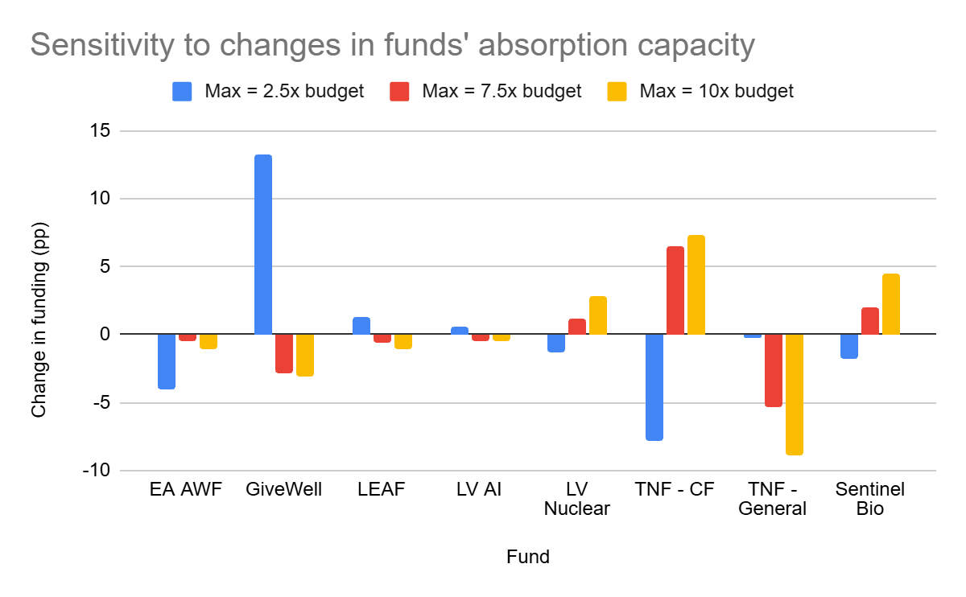

Combined – Changes in Rate of Diminishing Returns and Maximum Absorption
We wondered if the reason why the allocation isn’t very sensitive to changes in the rate of diminishing marginal returns (DMR rates) is because the funds hit their funding cap before differences in the DMR rates can show up. Potentially, if funds could absorb much more additional funding than we currently assume (5x their current budgets), then differences in DMR rates could begin to be more significant.

To test this, we tested variations in the rates at which the GCR and animal welfare funds’ returns diminish alongside different caps for the maximum funding that can be absorbed by each fund (2.5x, 5x, 7.5x, and 10x the current budget). We do find some evidence of this hypothesis: at the 10x budget cap, the portfolio shift is 6pp greater when GCRs and AW’s returns diminish slowly than when their returns diminish quickly, which exceeds the difference in portfolio shifts at lower budget caps. But even at an absorption cap of 10x current budgets, it appears that most of the portfolio shift for each test can be explained by changes in the absorption cap rather than changes in the DMR rates. We could dig in deeper to see how sensitive individual fund-level allocations are to changes in DMR rates at the 10x absorption cap.
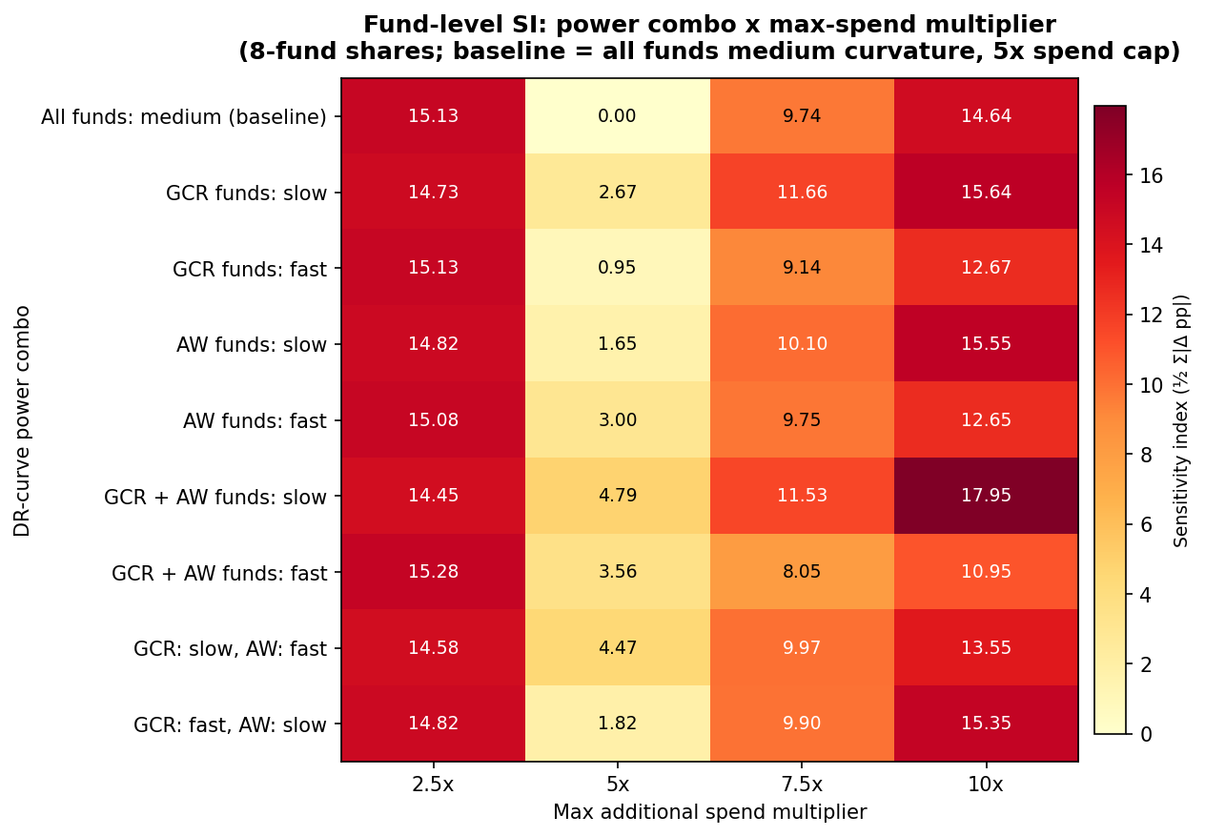

GCR parameter variations

Illustrative Example: Risk aversion
In the section analysing the sensitivity of the allocation to worldview credences, we noticed that risk aversion seemed to be playing a large role in defining which funds each worldview preferred. Here, we attempt to measure this effect directly.

Note, unlike the other sensitivity analyses, we don’t endorse placing full credence in any particular risk profile. Instead, these are meant to be illustrative examples to show how much risk profiles matter for the allocation across funds.

Methodology

We performed three types of tests to estimate the effect of risk aversion on the model’s recommended allocation.
- First, we tested what the recommended allocation would look like if all of the worldviews had the same risk profile. In this case, only moral weights, time preferences, and the discount for AI-related uncertainty would differentiate each worldview.
- Secondly, we tested what happens to the recommended allocation if all worldviews’ risk preferences were switched to one of the five risk-averse alternatives (e.g. from neutral to moderate weighted linear utility).
  - This test emphasizes the impact that each risk attitude has against a risk-neutral baseline
- Third, we tested what happens to the recommended allocation if all worldviews’ risk preferences were switched from the model’s baseline inputs (which places credence on various risk attitudes) to one risk attitude for all worldviews.
  - This test illustrates the effect of narrowing down our risk preferences from highly uncertain (which they are now) to a more certain position.

Allocation with One Risk Profile
The figure below shows what the recommended allocation to each fund would look like if we placed 100% of our credence in one risk profile, such that all worldviews had the same risk profile (but still differed as they do now in moral, temporal, and AI-related weights).

As we can see, having a substantial credence (40%) in risk-neutrality is the main contributor to our baseline recommendation to donate around 23% of the $200M budget on Longview’s AI fund. Holding all else equal, weighted linear utility and the combination of discounting outliers while upweighting negative results prefer the global health and development and animal welfare funds. (In fact, under these risk profiles, our assumption that the AI fund may have a 15% chance of causing harm means it is viewed as being net-negative on risk-adjusted terms).

Interestingly, Sentinel Bio and Longview’s Nuclear Weapons Policy Fund – only receive a substantial amount of funding under worldviews that don’t discount upsides (like WLU, upside skepticism, and the combined profiles do) but are averse to causing harm. This is in part because these funds, while they aren’t expected to do as much good as the Longview Frontier AI fund, we assume they’re less likely to pursue interventions that backfire and raise x-risk levels. However, these two funds’ are also assumed to have a high chance of having zero impact, such that their value is substantially driven by tail-end scenarios wherein they save many, many lives. This means that they’re dispreferred to funds in the animal welfare and GHD spaces that have more rapid feedback loops and can measure impact.
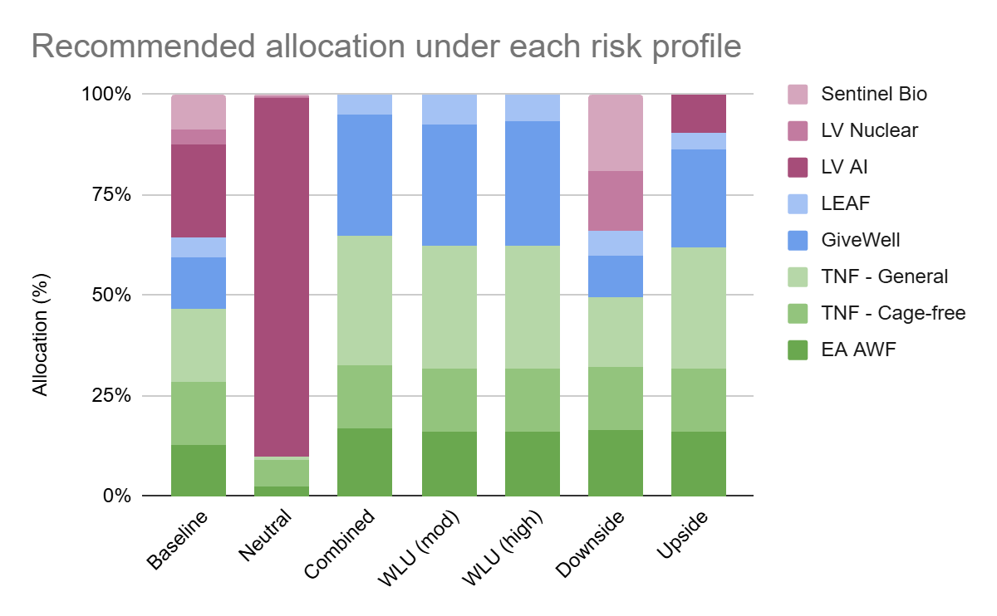

Sensitivity to Shift from Risk-Neutral to Risk-Averse
As we can anticipate, the recommended allocation is extremely sensitive to a donor having any level of risk aversion (compared to risk neutrality). This tends to come at the expense of funds that have a higher chance of backfiring–in this case, Longview’s Frontier AI Fund–and tends to promote the greater diversification among funds and cause areas we see in our baseline recommendations.

Starting Risk Profile | Final Risk Profile | Total portfolio shift (pp) | Between-causes portfolio shift (pp) | Share of shift between-causes (%) | Largest gain | Largest loss
Neutral | Upside skeptical + Downside critical | 90 | 90 | 100% | TNF - General (+31pp), GiveWell (+31pp) | Longview AI (-89pp)
Neutral | WLU (moderate) | 90 | 90 | 100% | TNF - General (+30pp), GiveWell (+30pp) | Longview AI (-89pp)
Neutral | WLU (high) | 90 | 90 | 100% | GiveWell (+31pp) | Longview AI (-89pp)
Neutral | Downside critical | 89 | 56 | 63% | Sentinel Bio (+18pp) | Longview AI (-89pp)
Neutral | Upside skeptical | 81 | 81 | 100% | TNF - General (+29pp) | Longview AI (-80pp)

Risk Neutral to WLU/Combined
At the most extreme, shifting from risk neutrality to either weighted linear utility or “upside skeptical and downside critical” risk profile–which both downweights high positive outcomes and assigns additional weight to causing harm–shifts 90 percentage points of funding.

Nearly all of this funding shift comes from Longview AI losing 89 percentage points of funding. GiveWell and The Navigation Fund’s general farm animal welfare fund gain 62 points total from this reallocation.

Risk Neutral to Downside Critical
If one doesn’t downweight large positive outcomes but is still averse to causing harm, then Longview’s Frontier AI fund (the most risky fund) loses all of its funding, to the benefit of all other funds.
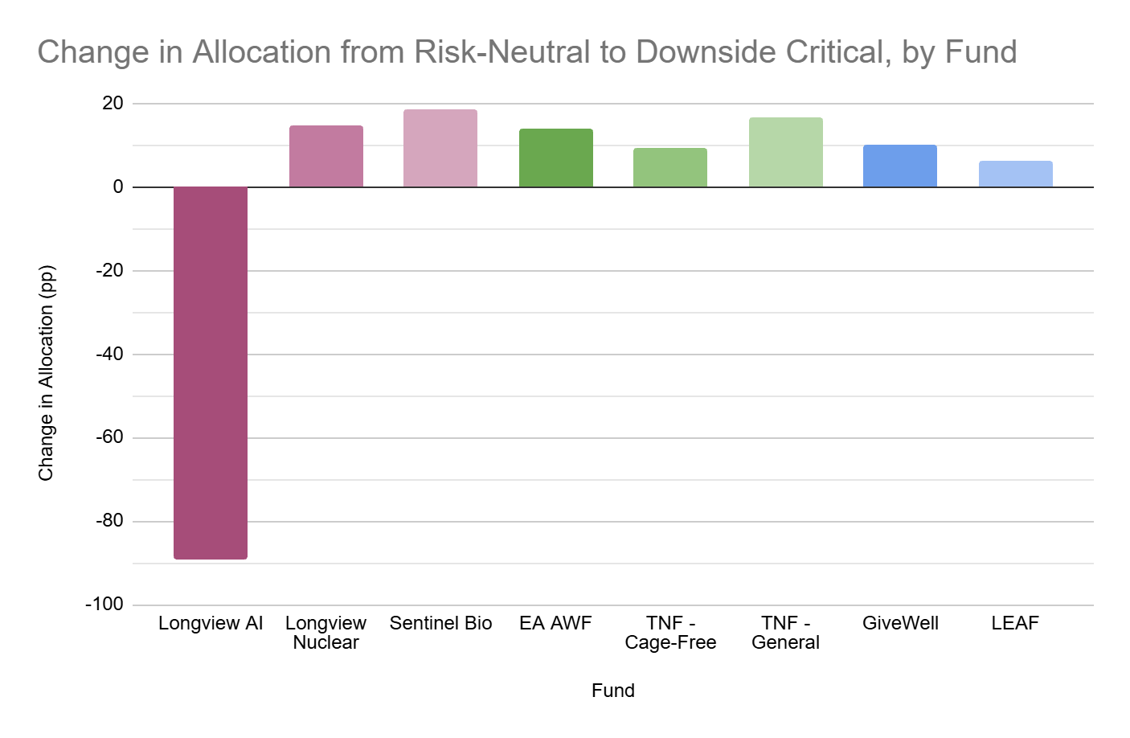

Risk Neutral to Upside Skeptical
What happens if you’re not especially averse to negative impacts, but you empirically disbelieve that the positive impacts could be as large as our models estimate?

As with the other tests, Longview AI’s fund loses most–but not all–of the funding recommended by the baseline allocation. Instead, spending flows to the animal welfare funds (TNF’s general fund, predominantly) and LEAF and GiveWell (which receive zero funding under the risk-neutral view).

Sensitivity to Shift from Baseline (Uncertain) to One Risk Profile
The above analyses help us quantify effect of risk aversion on one’s cause prioritization allocation. But they do not tell us how sensitive our baseline allocation is to changes in our risk profile.

Accordingly, our last risk aversion analysis captures how much our recommendations would shift if we put 100% credence in one risk attitude, instead of having worldviews with many risk preferences.

To do so, we tested what happens if all of the worldviews were to adopt a single risk attitude. They would still differ on other dimensions like moral weights and temporal discounts, but we’d effectively be asserting that we’ve narrowed down our uncertainty about risk to one particular attitude. The table below shows the results of this test.

Starting Risk Profile | Final Risk Profile | Total portfolio shift (pp) | Between-causes portfolio shift (pp) | Share of shift between-causes (%) | Largest gain | Largest loss
Baseline | Neutral | 66 | 55 | 83% | Longview AI (+66pp) | TNF - General (-17pp)
Baseline | Upside skeptical + Downside critical | 36 | 36 | 100% | GiveWell (+18pp) | Longview AI (-23pp)
Baseline | WLU (moderate) | 36 | 36 | 100% | GiveWell (+17pp) | Longview AI (-23pp)
Baseline | WLU (high) | 36 | 36 | 100% | GiveWell (+18pp) | Longview AI (-23pp)
Baseline | Upside skeptical | 27 | 26 | 97% | GiveWell (+12pp), TNF - General (+12pp) | Longview AI (-14pp)
Baseline | Downside critical | 27 | 3 | 12% | Longview Nuclear (+11pp) | Longview AI (-23pp)

Overall, the allocation is extremely sensitive to our switching from our baseline blend of risk profiles to a single risk attitude–regardless of what that attitude is.
- The largest effect occurs if we adopt risk-neutrality for all the worldviews. In this case, Longview’s AI fund gains 66 percentage points of additional funding (ending up at 90% total, like we saw earlier).
- Switching from our baseline to either version of WLU or the “combined” upside skeptical and downside critical attitudes has very similar effects on the resulting allocation.
  - Doing so moves 36 percentage points, mostly away from Longview AI and towards GiveWell.
  - Sentinel Bio and Longview’s nuclear fund also lose funding, whereas the animal welfare funds all gain funding (see the figure below)
  - LEAF gains an additional 2-3 percentage points of funding under WLU, but slightly loses funding under the combined view.

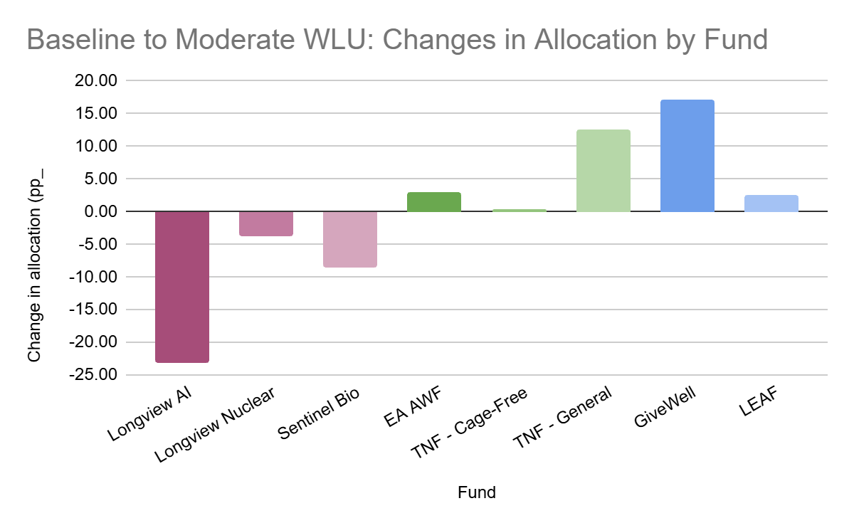

- Adopting the upside-skeptical view shifts funding largely away from all three GCR funds, since these funds’ expected value is concentrated in the top few percent of outcomes that are, under this view, heavily discounted or truncated. GiveWell and all three animal welfare funds gain, and LEAF slightly loses funding.
- Finally, adopting a downside-critical only view that gives special weight to avoiding negative outcomes benefits Sentinel Bio and Longview’s Nuclear Weapons Policy Fund the most, at the expense of Longview’s Frontier AI fund.
  - Sentinel Bio and Longview’s Nuclear Weapons Policy fund are modeled to have a lower chance of backfiring than, and thus are preferred substantially to, the Frontier AI fund.
  - Moreover, since this view doesn’t discount the right tail of outcomes, Sentinel Bio and the Nuclear Weapons Policy Fund still score well because they have a small chance of having an enormous impact.

Given the LEAF fund manager’s wide uncertainty interval around the cost-effectiveness of LEAF, it seems possible that our estimate could be 50% to 100% too low.
For example, if in one analysis we reduce the credence in total utilitarianism from 10% to 5%, and if person-affecting contractualism received 10% of the credence prior, then we distribute (10%/90%)*(10%-5%)=0.55% additional credence to person-affecting contractualism.
This makes sense, since if one is completely risk-neutral, the mean effect size of the GCR interventions is on the order of 10-19. Risk aversion reduces the value of these interventions, but the multiplier discount needs to be really quite small for there to be a meaningful impact on the allocation, since the expected value of reducing x-risks could be quite high.
The fifth set of weights was similar to the lowest moral weights, so we excluded it for this analysis.

